Enterprise Frameworks

PicPop Technical Report



Authors:

Ionel Pal (X11471146)

James Fahy (X14108704)

Pablo Jesus Gomez (X13122771)

A Report submitted in partial fulfillment of the requirements for

**MSc in Web Technologies**

**National College of Ireland**

Date of Submission – 13 November 2015

Contents

Motivation 8

Background research and investigations 9

Benefits and features 10

Planned developments 11

Project Plan 13

Software development methodology employed 13

Technology 13

Requirements Analysis 14

Introduction 14

Purpose 14

Project Scope 15

System architecture 16

Definitions 16

Enterprise 16

Architecture 16

Architecture Framework 17

Enterprise Framework 17

Enterprise Application 17

Web Application Framework 17

Why use a framework for enterprise architecture? 18

Use Cases 19

Description 19

Actors 19

Preconditions 19

Events flow 19

Set of Plans 20

Database 22

Benefits of Microsoft Azure SQL Database 22

Database Design Tools 22

Database Design 23

Entity Relationship Diagram 23

Database Schema 23

Domain Model 24

Object Relational Model (ORM) 24

Benefits of Entity Framework 25

Application Design 25

Architectural Patterns 26

Model-View-Controller (MVC) 26

Model-View-View-Model (MVVM) 27

Software Design Patterns 29

Repository Pattern 29

View Model Pattern 30

View Design Patterns 32

Top horizontal bar navigation 32

Vertical side bar navigation 32

Carousel 32

Thumbnail 32

Account Registration 32

Shopping Cart 32

Watermark 32

Pagination 33

Additional Technologies Implemented 33

Web Service 33

Security 34

ASP.NET forms based authorization 34

Authorize 34

Validation 35

Enable client side validation 35

Enable server side validation 36

Scalability 36

Testing 37

NUnit Testing 37

User Testing 38

User Testing 38

Requirements 38

Create Test Data 38

Appendix 1: Database 46

Appendix 2: Domain Model Diagram 55

Appendix 3: Project Plan 56

Project Overview 56

1) Background Research 56

2) User requirements and analysis 56

3) Wireframe Design 57

4) Database Design and Modelling 57

5) Object Design and Modelling 57

6) Screen Design 57

7) Technical Requirements 57

8) Data requirements 57

8.1) 57

7.3) 58

9) System Architecture 58

10) Functional Specifications 58

11) Implementation Specifications 59

Common Functionality 59

Unit Functionality 59

12) Testing 60

13) UI Presentation 61

14) Project Presentation 61

15) Technical Report 61

Appendix 4: Wireframes 65

Home 65

Register 66

Login 67

All Images 68

My Images 69

Image Details 70

Categories 71

Shopping Cart 72

Admin 73

User Roles 74

Contact Us 75

# Motivation

The purpose of this project is to develop the skills required to build a web application that uses Enterprise Frameworks.

This project was specifically requested to develop a Web application using the ASP.Net Enterprise Framework platform. It has to be multi-layered, exhibit separation of concerns and use design patterns in the application architecture. The design patterns should be useful, in the sense that they solve a particular problem that they were intended to. They should not be used just for the sake of it.

We developed an on-line market application for the purpose of buying and selling images using an image repository. We developed and ASP.Net MVC application using C#, HTML5 and CSS. That data are persisted in a Microsoft SQL Server Database that resides on the Microsoft Azure Cloud platform. A user can register with the website. When registered, the user can upload images which are stored as blobs in the repository. Image details are displayed in both carousel and gallery format.

# Background research and investigations

According to ‘SmartInsight.com’ (Smart Insights), the usage of mobile devices is overtaking the usage of desktop machines.

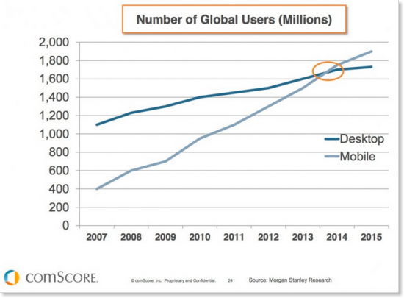

Fig. 1 Mobile v Desktop usage (Smart Insights)

Most of these mobile devices are equipped with good cameras. Most people are quite familiar with the latest technologies and sharing images with others is a quite natural thing to do. We believe there is a potential market for individuals and media outlets to profit from this sharing of good quality images that is facilitated by the internet.

According to Money Guide Ireland

“These has been a massive increase in the use of smartphones in Ireland, it is estimated there were 2.7 million active smartphone SIMS at the start of 2015.”

<http://www.moneyguideireland.com/prepay-mobile-internet-and-data-charges-in-ireland.html>

This figure is likely to grow. Not only are smartphones pervasive in Ireland but they are increasingly favoured for accessing the Web versus PC and Tablet devices.

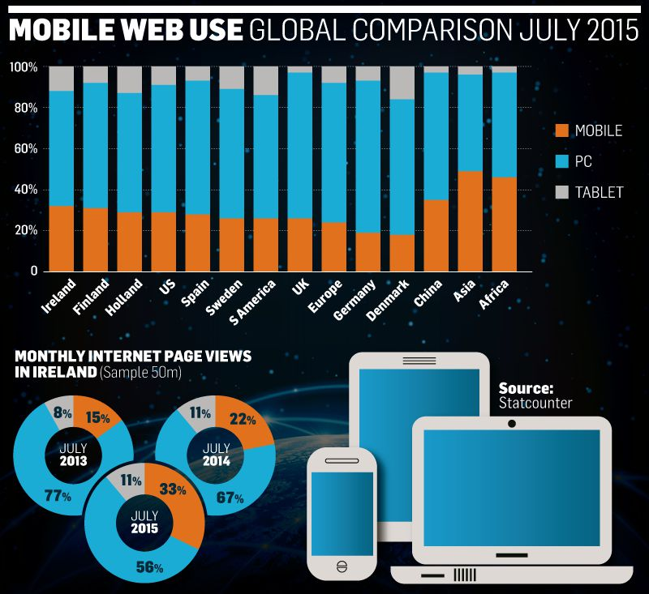

<https://twitter.com/statcounter>

## Benefits and features

Paying and receiving payment, for images with exclusive publishing rights, can be a good income source for individuals and media outlets.

Many applications are implementing similar functionality to our project objectives, but according to our research, there is a niche for ordinary people taking photos of current events as they unfold, and with the ability to share these images for small commission. The target is not professional photographers with high-end cameras. The target is ordinary people with smart mobile devices that contain good cameras.

Adding mobile image upload functionality, with a user-friendly interface, straight to the image repository can increase significantly the popularity of the application, as according to our research (Smith, 2015), most social network images are taken by smart phones and mobile devices.

Our target, are people who own high quality images from events around the world, i.e. a person can take images from a natural disaster, or any special event or social activity, and like to sell them to other people or media outlets, to transfer over the image property rights to different users or media companies, etc.

Users and media outlets can use the application to help them sell or resell their images to any potential buyers who are subscribers of the service provided by the application.

The application proposes to implement a well-categorized, high quality image repository for any potential seller and buyer, under commission charge and under a well-defined policy regarding image exclusivities rights, etc.

Casual users who have not subscribed and signed in should be able to view good quality watermarked versions of the images in the repository in order to protect our intellectual property.

Unique selling points

* Market for amateurs that does not currently exist

Advantages to media outlets

* One-stop shop. No need to have relationship with individuals that are selling images
* Ability to purchase good quality images relatively cheaply.
* Access to real-time imagery from anywhere in the world

Advantages to individuals selling images

* No need for relationship with multiple media outlets
* Images available to any media outlet that cares to look. i.e. more opportunities to sell.
* Make some money

Disadvantages or weak points

* The promoters are experienced software developers but none have experience of running their own business, never mind an online market place.

Though there currently are no businesses serving our intended market, competition is to be expected from businesses experienced in running online market places, especially those serving the professional image market.

## Planned developments

A professional implementation, with modular architecture, will allow the project to be flexible and open to new functionality and services.

The implementation of the application will apply design principles and design patterns with a multi-tier architecture.

The aim is to develop a web application that implements an image repository with a web access portal that allows individual users and media outlets to subscribe, communicate and exchange images in a fast and professional manner, or under a membership fee subscription.

Initially a mobile responsive web application will be developed but it is also planned to develop mobile and table apps that will run natively on multiple operating systems, including iOS, Android and Windows.

# Project Plan

Project plan see Appendix 1. This includes a description of all tasks identified and explained. It also shows resource allocation and timelines.

# Software development methodology employed

Prototype model

Before proceeding to final design and coding a prototype is developed to facilitate an understanding of the requirements. This prototype is built based on the currently known requirements. The interactions with the prototype help the developers and users to get a feel for the system which facilitates a better understanding of the the requirements of the desired system. It is an iterative process.

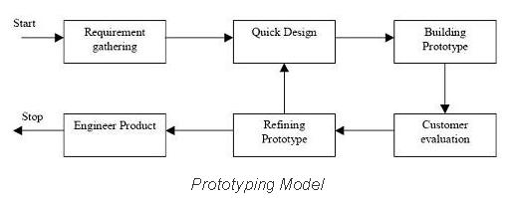

<http://istqbexamcertification.com/what-is-prototype-model-advantages-disadvantages-and-when-to-use-it/>

The prototype does not go into detail. The main aim is to flesh out the overall functionality. Prototyping is a particularly useful tool for complex systems that have no manual process or existing system to help determine the requirements. It is also a good methodology to use when the system has a lot of user interactions, as opposed to a process that can be largely automated. Online systems with web interfaces would be in this category.

The continuous feedback into the prototype design should result in system that the user will find easy and enjoyable to use.

# Technology

The technology we used on the project includes

Framework: Visual Studio ASP.Net MVC5

Languages: C#, JQuery, HTML, CSS

Database: Microsoft Azure SQL

Database Design: Entity Designer within SQL Server Explorer

Prototyping: Balsamiq

Styling: Bootstrap

Addins: flexslider.js, prettyPhoto.js, isotope.js, font-awesome.css

# Requirements Analysis

## Introduction

### Purpose

The aim of this project is to develop a web application, '*PicPop'*, that implements an image repository with a web access portal that allows individual users and media outlets to subscribe, communicate and exchange images in a fast and professional manner, or under a membership fee subscription.

The application has sufficient complexity to build skills in the area of Enterprise Application Frameworks and Rich Internet Applications.

Users will fall into three groups

* Admin
* Standard
* Anonymous

Our target, are people who own high quality images from events around the world, i.e. a person can take images from a natural disaster, or any special event or social activity, and like to sell them to other people or media outlets, to transfer over the image property rights to different users or media companies, etc.

Users and media outlets can use the application to help them sell or resell their images to any potential buyers who are subscribers of the service provided by *PicPop*.

The application proposes to implement a well-categorized, high quality image repository for any potential seller and buyer, under commission charge and under a well-defined policy regarding image exclusivities rights, etc.

Anonymous users, who have not logged-in, should be able to view good quality watermarked versions of the images in the repository in order to protect our intellectual property.

### Project Scope

The scope and complexity of *PicPop* is in the perspectives of each of the user groups outlined in the introduction.

As *PicPop* has a very short development lifecycle we are applying the MoSoCo principle in order to prioritise the functionality we will develop. It is important to understand that some features that do not make it into the *Must Have* category in this project e.g. E-Commerce capability, would, in a commercially deployed application, most definitely be in the *Must Have* category.

Must Have

**Admin** users have access to all aspects of the application and data.

They will be able to

* Edit users
* View correct versions of all images

An Admin user who is not logged-in will be treated as an Anonymous user.

**Standard** users do not have Admin privileges and are logged-in to *PicPop.*

They will be able to

* Upload images
* Remove images
* View correct versions of own images
* View correct versions of images bought previously
* View watermarked version of other images
* Shopping cart functionality
* Logout

A Standard user who is not logged-in will be treated as an Anonymous user.

**Anonymous** users are not logged-in to *PicPop.*

They will be able to

* View watermarked version of all images
* Register with the web site
* Remember password
* Login

Should Have

Could Have

* Buy images
* Sell images
* E-Commerce module. The ability to process payments.
* Financial account module
  + List of payments received transactions (images sold)
  + List of payments made transactions (images purchased)
  + Account balance
* Email module. Notification of payments made and received.
* Comments/Reviews module

## System architecture

## Definitions

### Enterprise

|  |
| --- |
| *“...is any collection of organizations that has a common set of goals and/or a single bottom line. In that sense, an enterprise can be a government agency, a whole corporation, a division of a corporation, a single department, or a chain of geographically distant organizations linked together by common ownership.*  *The term "enterprise" in the context of "enterprise architecture" can be used to denote both an entire enterprise, encompassing all of its information systems, and a specific domain within the enterprise. In both cases, the architecture crosses multiple systems, and multiple functional groups within the enterprise.”* |
| *The Open Group:* <http://pubs.opengroup.org/architecture/togaf8-doc/arch/> |

### Architecture

|  |
| --- |
| *“The fundamental organization of a system, embodied in its components, their relationships to each other and the environment, and the principles governing its design and evolution.”* |
| *ANSI/IEEE Std 1471-2000: Page 10,* <http://www.enterprise-architecture.info/Images/Documents/IEEE%201471-2000.pdf> |

### Architecture Framework

|  |
| --- |
| *“…is a tool which can be used for developing a broad range of different architectures. It should describe a method for designing an information system in terms of a set of building blocks, and for showing how the building blocks fit together. It should contain a set of tools and provide a common vocabulary. It should also include a list of recommended standards and compliant products that can be used to implement the building blocks.”* |
| *The Open Group:* <http://pubs.opengroup.org/architecture/togaf8-doc/arch/> |

### Enterprise Framework

|  |
| --- |
| *“A complete environment for developing and implementing a comprehensive information system. Enterprise frameworks provide pre-built applications, development tools for customizing and integrating those applications to existing ones as well as developing new applications. They may also provide a workflow component.”* |
| *PC Magazine:* <http://www.pcmag.com/encyclopedia/term/42643/enterprise-framework> |

### Enterprise Application

|  |
| --- |
| * *provides effective functionality to support an organisation’s business processes in an efficient manner* * *Must meet specific business requirements* * *Provide high quality user interface* * *Usually ‘large’ – i.e., multi-user, multi-machine, multi-component applications that access and manipulate large volumes of data and other network distributed resources* * *Often ‘mission-critical’ – i.e., there is a serious risk that the organisation* * *will not be able to function correctly if the application fails or becomes unavailable* |
| *NCIRL (Enterprise Application Frameworks) :* <https://moodle.ncirl.ie/pluginfile.php/21164/mod_resource/content/1/Enterprise_Application_Frameworks_1.pdf> |

As we are building a web application we are specifically interested in an enterprise level web application framework.

### Web Application Framework

|  |
| --- |
| *“A type of framework, or foundation, specifically designed to help developers build web applications. These frameworks typically provide core functionality common to most web applications, such as user session management, data persistence, and templating systems. By using an appropriate framework, a developer can often save a significant amount of time building a”* |
| *DocForge:* <http://docforge.com/wiki/Web_application_framework> |

## Why use a framework for enterprise architecture?

Enterprises use complex business processes and IT applications that encapsulate this functionality are often complex themselves. Architecture can provide structure for business and technology processes. Without structure anarchy soon reigns and the IT systems will find it difficult to respond to the evolving demands of the business.

Using an architecture framework will simplify the development of IT systems and lead to efficient and timely responses to new business challenges. It will also ensure that the designed solution more completely covers the business requirements, and at the same time provide flexibility to respond to the future needs of the business.

*PicPop* will be developed using Microsoft’s ASP.NET web development framework. It will also use Web API, EntityFramework, C#, SQLServer, AngularJS, Bootstrap and Azure technologies. The MVVM design pattern will be used in order to make the application dynamic and responsive.

# Use Cases

## Description

The application can be accessed online and can be used to buy or sell images.

PicPop users can use the application to view all images and upload new images to their own repository for sale. They can edit or delete their own images.

Admin users have full control over all images and can customise the categories.

### Actors

* Users buying images
* Users selling images
* Admin

### C:\Users\x\Desktop\Drawing1.jpg

### Preconditions

Desktop or mobile device with any browser type and with an internet connection.

### Events flow

Plans:

1. PicPop Image Repository sell or buy images
2. The use case starts when a user opens a browser and surfing to the PicPop Url.
   1. Website is loading fast and no errors are displaying on the user’s interface.
   2. Check interface is working properly.
3. View images
   1. View all images
      1. Select an image
         1. View image details
            1. Add image to cart
         2. Add image to cart
   2. View images by category
      * 1. Select an image
           1. Add image to cart
        2. Add image to cart
4. User authentication
   1. Login
      1. Login as a standard user
         1. View own images
            1. Upload new images
            2. Edit a personal image details
            3. Delete a personal image
         2. Add image to cart
      2. Login as an admin
         1. Add new image category
         2. Access to all images to edit and delete functionality (images should get admin approve before going live on the interface)
      3. Recovery password
   2. Sign-up for a new account
5. Cart
   1. Check out
   2. Delete image from cart
   3. Return to all images
6. Log-off

### Set of Plans

* **Plan 0:**

User do: 1, then 2 or 3 in any order, then 4 (If image(s) are added to cart), then 5.

OR

Do 1, then 3, then 5. (for admin or specific for only upload images)

* **Plan 1:** Do 1.1 or 1.2 in any order.
* **Plan 2:** Do 2.1 or 2.2 in any order.
* **Plan 3:**

**Do 3.1.1 or 3.1.2 in any order then (IF ADMIN login do 3.1.2.1 or 3.1.2.2 in any order) or for standard user do 3.1.1.1.1 or 3.1.1.1.2 or 3.1.1.1.3 in any order.**

**OR**

**Do 3.2 if new user.**

* **Plan 4: Do 4.1 or 4.2 or 4.3**

# 

# Database

We went for a cloud bases option for PicPop. The database is a Microsoft Azure SQL Database. We are experienced SQLServer database developers and it has all the tools we need to for this application.

## Benefits of Microsoft Azure SQL Database

* High-availability, Disaster recovery, Easy upgrade path
* Managed Platform, operating system, hardware, and configuration settings. Can focus on application development.
* Applications using scale-out patterns.
* Database-as-a-Service. High compatibility to SQLServer
* Databases of up to 1 TB in size.
* Building Software-as-a-Service applications.
* No hardware costs
* Reduced admin costs
* Familiarity of team members with SQLServer databases

## Database Design Tools

The database was designed using the SQL Server Explorer object in Visual Studio. This provides most of features of SQLServer Management Studio. All the usual relation database objects can be designed with this tool, including tables, views, indices, primary and foreign key constraints. The objects can be constructed using the built in form designers for each object. Panels within the window display the schema code and also a list of the object properties, as you make changes in the form. As an example see Fig 1 below. The database schema is automatically created from the design.

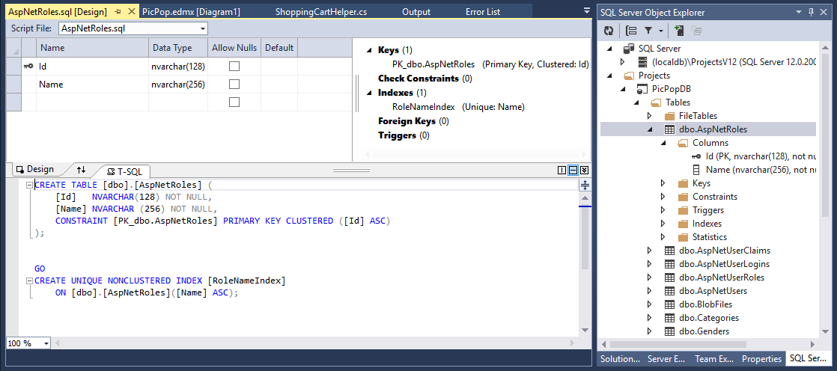

Fig. 1 Table Designer in SQLServer Explorer

As the development progressed we found it very easy to add new objects, including, tables, fields and foreign keys. As mentioned previously the schema is generated automatically. A few clicks is all it takes to upload the schema to the Azure server.

## Database Design

The database was designed based on the requirements analysis, the prototype development and further user input. The database tables and relationships are outlined below in Fig 2 below.

### Entity Relationship Diagram

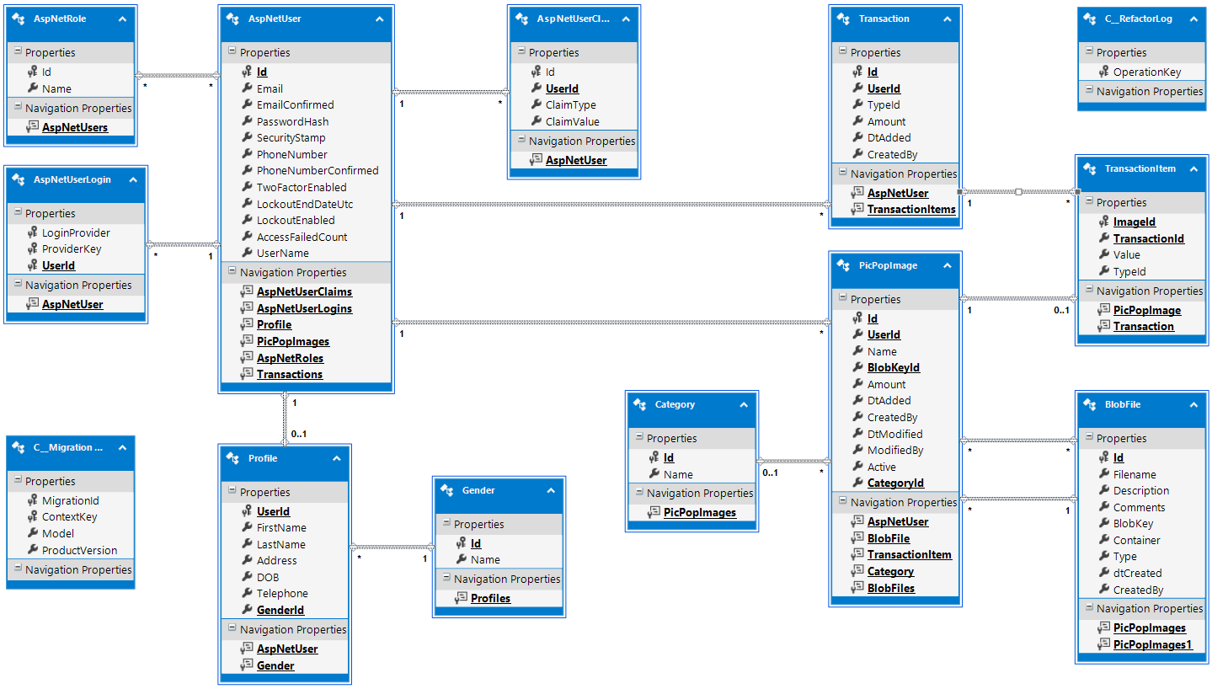

Fig 2. Entity Relationship Diagram

### Database Schema

The database schema was generated using the Entity designer in SQL Object Explorer of Visual Studio. For the full schema see Appendix III

# 

# Domain Model

All team members are experience SQL developers so we used a database-first approach to build our domain model. This ensures a close alignment between our database and the domain model and reduces the chances the risk of our model not persisting to the database.



# Object Relational Model (ORM)

We used the Microsoft’s Entity Framework (EF) which is an object relational mapper. It is a component of the .Net framework and will run wherever .Net (3.5 or later) is installed.

EF works behind the scenes to map our domain model objects to relational database entities. Our .Net application does not need to know the details of data-access and how the domain objects are persisted to the database. EF maps relational database tables to Plain Old CLR Objects (POCOs). Our Domain model uses and extends these objects. The design of the application can take an Object-Oriented approach which is very important in complex enterprise-scale systems.

There are a couple of paths to producing our Domain Model

* Code-First: Develop the Domain Model from scratch and allow EF to generate the database schema.
* Database-First: Build the Database, and allow the EF to generate the Domain Model. The model can be extended and it only takes a couple of clicks to update the database structure. As all team members are experienced SQL developers, this is the approach we followed.

We used EF to map in the early stages to Microsoft’s localDB and later to Azure SQL. It works with many more DBs and it allows an easy upgrade path to other more enterprise-scale DBs, such as Microsoft SQL Server, should we need to scale-up the application.

## Benefits of Entity Framework

* Enhanced productivity. No need to write data access routines.
* Data-access code is under source control. Always a problem with relational schemas.
* The conceptual model is better represented by the domain model than with a relational schema.
* Clear separation of concerns between the persistence layer and the business logic layer.
* Language Integrated Query (LINQ) allows the developer to write sophisticated queries against the domain model without going near SQL to the database.

# Application Design

The application follows a layered approach

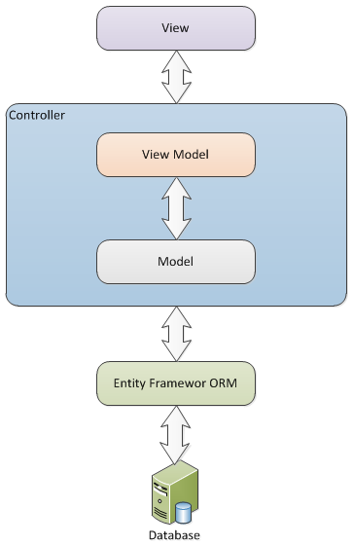

## Architectural Patterns

### Model-View-Controller (MVC)

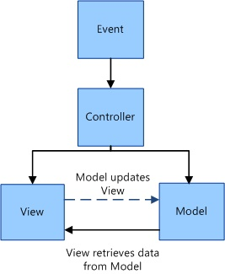

This MVC architectural pattern was developed by Trygve Reenskaug at Xerox PARC in the 1970s. It separates software into three layers, the model, the view and the controller. This separation of concerns means that in theory at least, any one layer could be, completely rewritten or exchanged for an alternate and the application would still work provided the interfaces remained the same.

The model (Domain Model) consists of the objects that represent the various business and process entities and their various relationships and behaviours. It comprises the business logic layer. Examples in our application would be the Blob File Model and the Shopping Cart Model.

The view deals with the presentation of the data, the user-interface. In our application, the views are comprised of various HTML pages. In theory, there could be multiple Views to represent the same data that would not require any change to the other layers. e.g. responsive web pages, mobile native client. This is separation of concerns, or loose coupling, in action

The controller acts as the glue between the model and the view. It receives instructions from the view to either, retrieve data from the model or to update the model. The controller manages the Use cases, i.e. the user actions e.g. Display Images or Update Profile. When the model’s state has changed, the controller will update the view with the details.

Originally developed for desktop applications, it has become a cornerstone of many web applications. It is the default design pattern for many web application frameworks, such as Ruby on Rails, which we studied in the first semester of Year 1. It is the main design pattern in Microsoft’s ASP.Net MVC framework, which we have used for this project

In its’ earlier days MVC operated as a server-side technology. Newer frameworks such as Angular JS, Ember.js and Backbone use the MVC pattern on the client-side also.

The MVC pattern has also evolved variations such as MVA, MVP, and MVVM.

### Model-View-View-Model (MVVM)

This is variation of the Presentation Model architectural pattern developed by Martin Fowler. MVVM was developed at Microsoft to simply event-driven programming for user interfaces. It also is known as Model-View-Binder.

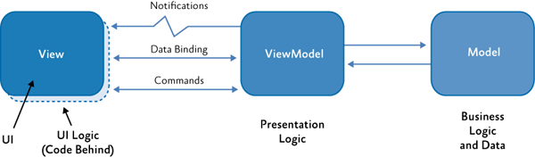

The Model represents the data, as in MVC.

The View is more dynamic than in the MVC interpretation. It contains behaviours, events and data-bindings that require knowledge of the View-Model.

The View-Model contains properties and methods that are bound to elements in the View. For example, if a user clicks a submit button on a form, a method in the View-Model will be called that interacts with the Model and the properties will be updated. Changes to the properties automatically propagate to the view.

#### MyImages Example

The MyImages view is bound to the ImageDetailsViewModels

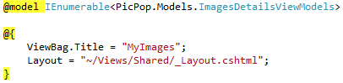

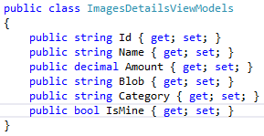

The Images controller takes data from the domain model (List<PicPopImage> lst), passes it to the view model (IEnumerable<ImagesDetailsViewModels> model), and on to the view (View(model)).

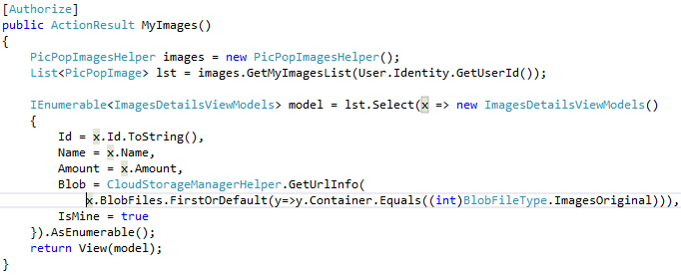

#### Upload Image Example

If the user clicks a button in the view to upload a new image



The Images controller takes data from the view model (ImagesCreateViewModels images) , passes it to the domain model (PicPopImage image), and updates the view (View(images)) .

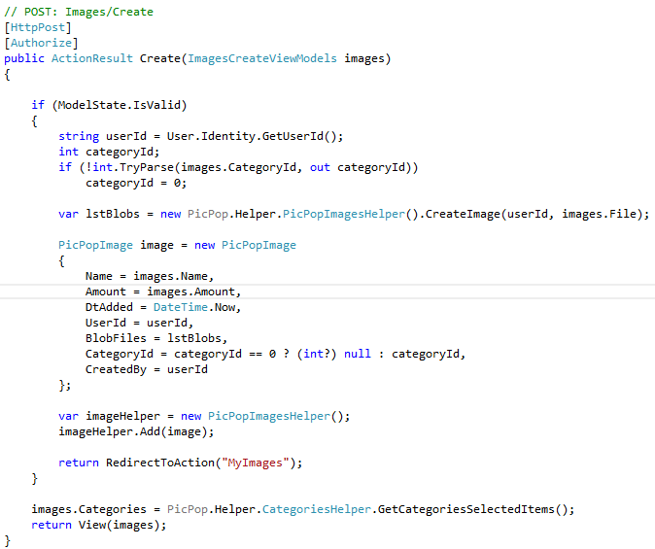

## Software Design Patterns

### Repository Pattern

In the business logic layer, we have created an abstract interface for data-access.

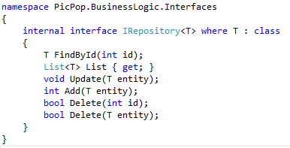

The various helper classes implement this shared interface. Business logic is implemented in the methods. Here is the Categories helper as an example

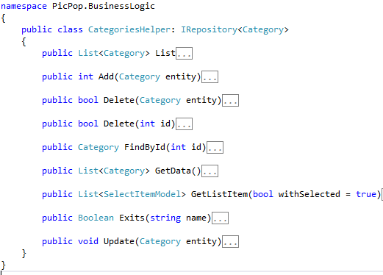

### View Model Pattern

The view models act as containers to render what we need displayed in the views. It is a stricter attempt to enforce separation of the model and the view. The controller intermediates between the domain model and the view model.

#### Helper Classes

Repository -> ImagesDetails -> ImagesHelper -> ImagesDetailsViewModel -> View

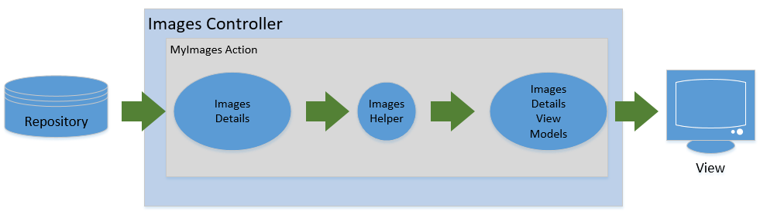

Controller

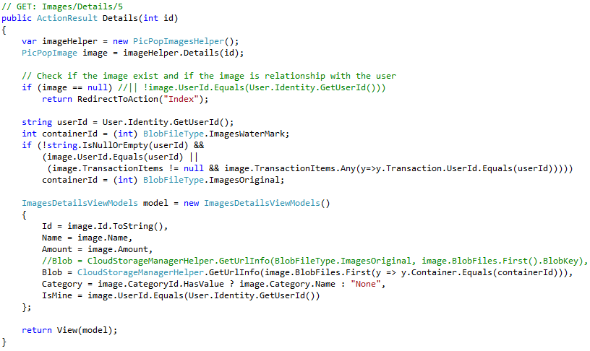

Helper

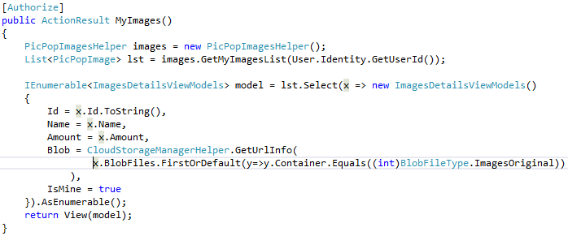

View Model



While the above action returns a view, validation can be done on the view model, for create and update actions, rather than on the model. The loosens the coupling of the model and view even more.

## View Design Patterns

### Top horizontal bar navigation

We used the Top horizontal bar navigation pattern for site navigation. It is located directly above the site header of all web pages in our application.

### Vertical side bar navigation

The application is a responsive design and the navigation will toggle to vertical side bar when the display device is narrow. This makes navigation a lot easier for those accessing the application on a mobile device.

### Carousel

The Carousel pattern is used in the home page. It auto-rotates through a limited sequence of images to give the new user a flavour for what is uploaded to the site. It makes efficient use of screen real-estate while providing the user with an engaging experience.

### Thumbnail

The Thumbnail pattern is great when the user needs to get an overview of multiple pictures without having to download each of the full size images. This is used in the Images and MyImages pages.

### Account Registration

The Account Registration design pattern comes as a standard option when creating an ASP.Net MVC application. It is necessary in this application because we need to provide personalised content to users for example a list of images owned or purchased by a user. It is also necessary to ensure that users are remunerated for images that they have sold. It is accessed from the top horizontal navigation bar

### Shopping Cart

The shopping cart pattern is useful when users may want to purchase multiple items. Checkout needs only happen once when the user has finished shopping. This is implemented on the Images page.

### Watermark

The watermark design pattern is useful for intellectual property protection in e-commerce applications. In our application a user can only see the correct version of an image that user has uploaded or has purchased. All other images are shown with a watermark.

### Pagination

The pagination design pattern is useful for when we have a large set but only need to display a portion at a time. For example, if a page had thousands of images to display in a large thumbnail format, then it would make sense to display only a small subset at any one time. It also lets the user know how big the data set is. The user can decide if they want to continue to browse onwards. We have implemented this in the All Images page.

# Additional Technologies Implemented

## Web Service

We call a weather related web service which is referenced in Service References.

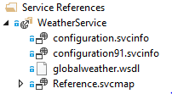

The data transfer protocol used is SOAP as described in the web.config file.

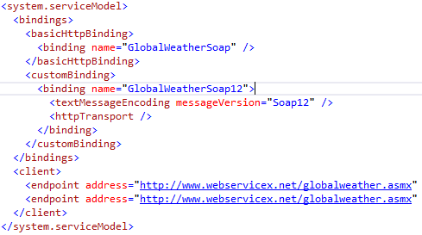

The location and temperature are displayed above the navigation bar



The service is called from the Home controller

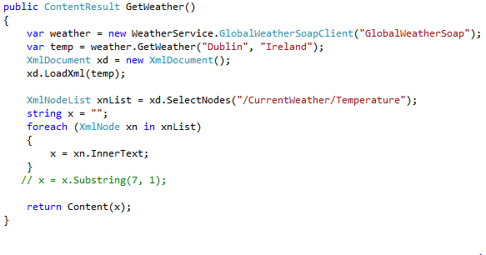

# Security

We use a dropdown list for filtering images displayed by Category.

## ASP.NET forms based authorization

We used the default register/login functionality that comes with the ASP.NET framework. This functionality auto creates the necessary tables on our database.

## Authorize

We use the ASP.NET login/registration functionality to register users to the application. This allows us to put authorization on our controllers and controller actions. The authorization requires that a user be registered before being allowed to access certain sections of the system. The registration process creates records in the AspNetUser and Profile tables.

A number of controllers need to confirm the identity of the user initiating the action, including

* ImagesController
* CategoriesController
* AccountController
* TransactionController
* ShoppingCartController

Authorisation can be at controller level for the logged-in user

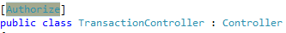

Or it can also be at controller level but extended to specific users or roles for example in the Categories Controller

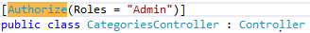

In addition, it can be at action level, for example in the Shopping Cart Controller

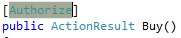

Additional security is implemented in the application using the HttpContext.Current.User to check if the current user is authenticated before proceeding.



## Validation

We used Data Annotations in our View Models. We want to enable both client side and server side validation. We should always have server-side validation in case javascript is disabled. Client side validation will make the application more responsive, as client side validation does not require a post to the server. Server side validation is also required in case form data has been compromised on posting of the data to the post action method.

### Enable client side validation

We add the following to web.config to enable client-side validation

### 

The MVC framework takes care of enforcing validation by using the [Required] annotation for example in the AccountViewModel

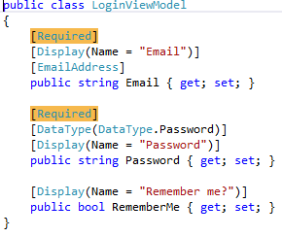

### Enable server side validation

We add the following to ensure server side validation. The ValidateAntiForgeryToken is used to eliminate cross-cutting concerns.



For example, in the Images controller

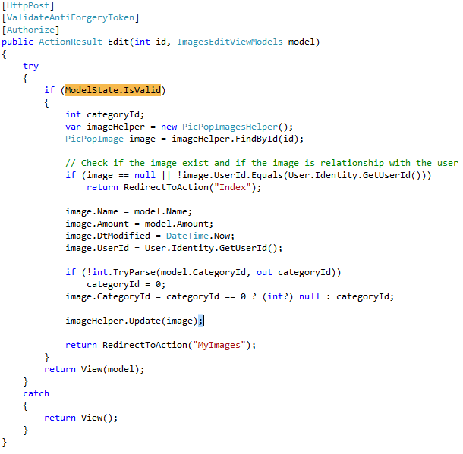

# Scalability

The architecture is constructed with separation of concerns in mind. The various layers are loosely coupled. It should be possible to create a mobile optimised native-client front-end without changing the business logic and domain model.

Additionally, external authentication using for example, Facebook or Google, would be relatively easy to implement.

Future code to be developed for transaction summary reporting. No change would be required to the domain model, just extra business logic and options in presentation.

Adding extra categories is simple. We could also add multiple categorisation to the model. This would be a little trickier and would require a change to the domain model.

# Testing

## NUnit Testing

Automated testing is a major productivity advantage when we want to verify that new functionality has not messed up older code. ASP.Net MVC provides a framework to do this.

We added a new project to the solution for this purpose. It just deals with validation of transactions.

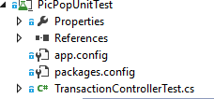

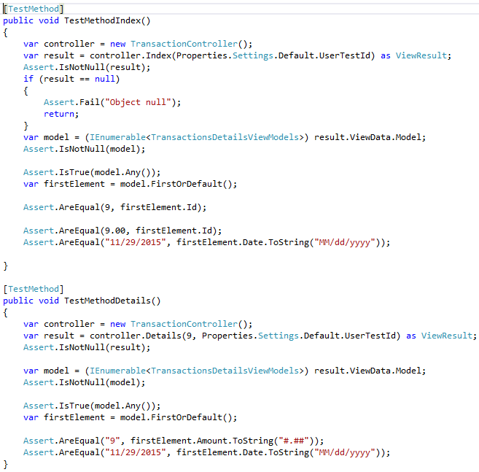

We created two test units as an example of how to go about it. Time-constraints meant that we did not implement tests across the domain model.

## User Testing

# User Testing

## Requirements

### Create Test Data

For testing purpose we need test all Use Case available in page 15.

1. User Registration

In this step we are testing is a new user can register successfully with the application.

We are register the following user [testuser@student.ncirl.ie](mailto:testuser@student.ncirl.ie) to the image repository application.



This brings the new user to the following page as per bellow image:



And here is the database screenshot:



1. Add new image to the repository and edit the details.

User can upload new image to the repository:



Here is the new image added in the ‘My Images’ page.



1. Update image category from football to Hurling





1. Browse specific images category



User selected a category and images are displayed by that category.



1. Add image to cart



Add the image to cart.



1. Update cart items

User can update cart details.



# Appendix 1: Database

Diagram

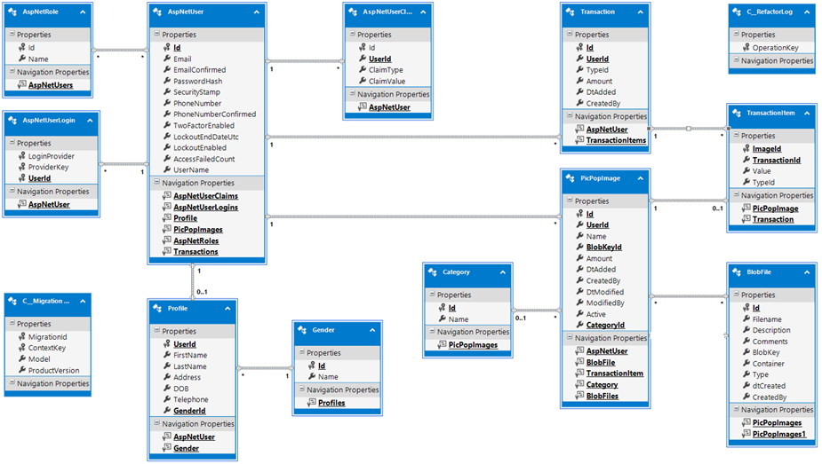

Schema

|  |
| --- |
| CREATE TABLE dbo.AspNetRoles(  Id nvarchar(128) NOT NULL,  Name nvarchar(256) NOT NULL,  CONSTRAINT PK_dbo.AspNetRoles PRIMARY KEY CLUSTERED  (  Id ASC  )WITH (PAD_INDEX = OFF, STATISTICS_NORECOMPUTE = OFF, IGNORE_DUP_KEY = OFF, ALLOW_ROW_LOCKS = ON, ALLOW_PAGE_LOCKS = ON)  )  CREATE TABLE dbo.AspNetUserClaims(  Id int identity(1,1) NOT NULL,  UserId nvarchar(128) NOT NULL,  ClaimType nvarchar(max) NULL,  ClaimValue nvarchar(max) NULL,  CONSTRAINT PK_dbo.AspNetUserClaims PRIMARY KEY CLUSTERED  (  Id ASC  )WITH (PAD_INDEX = OFF, STATISTICS_NORECOMPUTE = OFF, IGNORE_DUP_KEY = OFF, ALLOW_ROW_LOCKS = ON, ALLOW_PAGE_LOCKS = ON)  )  CREATE TABLE dbo.AspNetUserLogins(  LoginProvider nvarchar(128) NOT NULL,  ProviderKey nvarchar(128) NOT NULL,  UserId nvarchar(128) NOT NULL,  CONSTRAINT PK_dbo.AspNetUserLogins PRIMARY KEY CLUSTERED  (  LoginProvider ASC,  ProviderKey ASC,  UserId ASC  )WITH (PAD_INDEX = OFF, STATISTICS_NORECOMPUTE = OFF, IGNORE_DUP_KEY = OFF, ALLOW_ROW_LOCKS = ON, ALLOW_PAGE_LOCKS = ON)  )  CREATE TABLE dbo.AspNetUserRoles(  UserId nvarchar(128) NOT NULL,  RoleId nvarchar(128) NOT NULL,  CONSTRAINT PK_dbo.AspNetUserRoles PRIMARY KEY CLUSTERED  (  UserId ASC,  RoleId ASC  )WITH (PAD_INDEX = OFF, STATISTICS_NORECOMPUTE = OFF, IGNORE_DUP_KEY = OFF, ALLOW_ROW_LOCKS = ON, ALLOW_PAGE_LOCKS = ON)  )  CREATE TABLE dbo.AspNetUsers(  Id nvarchar(128) NOT NULL,  Email nvarchar(256) NULL,  EmailConfirmed bit NOT NULL,  PasswordHash nvarchar(max) NULL,  SecurityStamp nvarchar(max) NULL,  PhoneNumber nvarchar(max) NULL,  PhoneNumberConfirmed bit NOT NULL,  TwoFactorEnabled bit NOT NULL,  LockoutEndDateUtc datetime NULL,  LockoutEnabled bit NOT NULL,  AccessFailedCount int NOT NULL,  UserName nvarchar(256) NOT NULL,  CONSTRAINT PK_dbo.AspNetUsers PRIMARY KEY CLUSTERED  (  Id ASC  )WITH (PAD_INDEX = OFF, STATISTICS_NORECOMPUTE = OFF, IGNORE_DUP_KEY = OFF, ALLOW_ROW_LOCKS = ON, ALLOW_PAGE_LOCKS = ON)  )  CREATE TABLE dbo.BlobFiles(  Id int identity(1,1) NOT NULL,  Filename nvarchar(500) NULL,  Description nvarchar(256) NULL,  Comments nvarchar(max) NULL,  BlobKey nvarchar(500) NOT NULL,  Container int NOT NULL,  Type nvarchar(64) NULL,  dtCreated datetime NOT NULL,  CreatedBy nvarchar(128) NOT NULL,  CONSTRAINT PK_Blob_Files PRIMARY KEY CLUSTERED  (  Id ASC  )WITH (PAD_INDEX = OFF, STATISTICS_NORECOMPUTE = OFF, IGNORE_DUP_KEY = OFF, ALLOW_ROW_LOCKS = ON, ALLOW_PAGE_LOCKS = ON)  )  CREATE TABLE dbo.Cateries(  Id int identity(1,1) NOT NULL,  Name nvarchar(255) NOT NULL,  PRIMARY KEY CLUSTERED  (  Id ASC  )WITH (PAD_INDEX = OFF, STATISTICS_NORECOMPUTE = OFF, IGNORE_DUP_KEY = OFF, ALLOW_ROW_LOCKS = ON, ALLOW_PAGE_LOCKS = ON)  )  CREATE TABLE dbo.ErrorsLog(  Id int identity(1,1) NOT NULL,  UserName nvarchar(max) NULL,  UserAgent nvarchar(max) NULL,  Date date NULL,  Message nvarchar(max) NULL,  Method nvarchar(max) NULL,  Source nvarchar(max) NULL,  StackTrace nvarchar(max) NULL,  Url nvarchar(max) NULL,  PRIMARY KEY CLUSTERED  (  Id ASC  )WITH (PAD_INDEX = OFF, STATISTICS_NORECOMPUTE = OFF, IGNORE_DUP_KEY = OFF, ALLOW_ROW_LOCKS = ON, ALLOW_PAGE_LOCKS = ON)  )  CREATE TABLE dbo.Genders(  Id int identity(1,1) NOT NULL,  Name nvarchar(155) NULL,  PRIMARY KEY CLUSTERED  (  Id ASC  )WITH (PAD_INDEX = OFF, STATISTICS_NORECOMPUTE = OFF, IGNORE_DUP_KEY = OFF, ALLOW_ROW_LOCKS = ON, ALLOW_PAGE_LOCKS = ON)  )  CREATE TABLE dbo.ImagesBlobs(  ImageId int NOT NULL,  BlobId int NOT NULL,  PRIMARY KEY CLUSTERED  (  BlobId ASC,  ImageId ASC  )WITH (PAD_INDEX = OFF, STATISTICS_NORECOMPUTE = OFF, IGNORE_DUP_KEY = OFF, ALLOW_ROW_LOCKS = ON, ALLOW_PAGE_LOCKS = ON)  )  CREATE TABLE dbo.PicPopImages(  Id int identity(1,1) NOT NULL,  UserId nvarchar(128) NOT NULL,  Name nvarchar(255) NOT NULL,  Amount money NOT NULL,  CateryId int NULL,  DtAdded datetime NOT NULL,  CreatedBy nvarchar(128) NOT NULL,  DtModified datetime NULL,  ModifiedBy nvarchar(128) NULL,  Active bit NOT NULL,  PRIMARY KEY CLUSTERED  (  Id ASC  )WITH (PAD_INDEX = OFF, STATISTICS_NORECOMPUTE = OFF, IGNORE_DUP_KEY = OFF, ALLOW_ROW_LOCKS = ON, ALLOW_PAGE_LOCKS = ON)  )  CREATE TABLE dbo.Profiles(  UserId nvarchar(128) NOT NULL,  FirstName nvarchar(255) NOT NULL,  LastName nvarchar(255) NOT NULL,  Address nvarchar(255) NULL,  DOB datetime NULL,  Telephone nvarchar(50) NULL,  GenderId int NOT NULL,  PRIMARY KEY CLUSTERED  (  UserId ASC  )WITH (PAD_INDEX = OFF, STATISTICS_NORECOMPUTE = OFF, IGNORE_DUP_KEY = OFF, ALLOW_ROW_LOCKS = ON, ALLOW_PAGE_LOCKS = ON)  )  CREATE TABLE dbo.TransactionItems(  ImageId int NOT NULL,  TransactionId int NOT NULL,  Value money NOT NULL,  PRIMARY KEY CLUSTERED  (  ImageId ASC,  TransactionId ASC  )WITH (PAD_INDEX = OFF, STATISTICS_NORECOMPUTE = OFF, IGNORE_DUP_KEY = OFF, ALLOW_ROW_LOCKS = ON, ALLOW_PAGE_LOCKS = ON)  )  CREATE TABLE dbo.Transactions(  Id int identity(1,1) NOT NULL,  UserId nvarchar(128) NOT NULL,  TypeId bit NOT NULL,  Amount money NOT NULL,  DtAdded datetime NOT NULL,  CreatedBy nvarchar(128) NOT NULL,  CONSTRAINT PK_Transactions PRIMARY KEY CLUSTERED  (  Id ASC  )WITH (PAD_INDEX = OFF, STATISTICS_NORECOMPUTE = OFF, IGNORE_DUP_KEY = OFF, ALLOW_ROW_LOCKS = ON, ALLOW_PAGE_LOCKS = ON)  )  CREATE UNIQUE NONCLUSTERED INDEX RoleNameIndex ON dbo.AspNetRoles  (  Name ASC  )  WITH (PAD_INDEX = OFF, STATISTICS_NORECOMPUTE = OFF, SORT_IN_TEMPDB = OFF, IGNORE_DUP_KEY = OFF,  DROP_EXISTING = OFF, ONLINE = OFF, ALLOW_ROW_LOCKS = ON, ALLOW_PAGE_LOCKS = ON)  CREATE NONCLUSTERED INDEX IX_UserId ON dbo.AspNetUserClaims  (  UserId ASC  )  WITH (PAD_INDEX = OFF, STATISTICS_NORECOMPUTE = OFF, SORT_IN_TEMPDB = OFF, DROP_EXISTING = OFF,  ONLINE = OFF, ALLOW_ROW_LOCKS = ON, ALLOW_PAGE_LOCKS = ON)  CREATE NONCLUSTERED INDEX IX_UserId ON dbo.AspNetUserLogins  (  UserId ASC  )  WITH (PAD_INDEX = OFF, STATISTICS_NORECOMPUTE = OFF, SORT_IN_TEMPDB = OFF, DROP_EXISTING = OFF,  ONLINE = OFF, ALLOW_ROW_LOCKS = ON, ALLOW_PAGE_LOCKS = ON)  CREATE NONCLUSTERED INDEX IX_RoleId ON dbo.AspNetUserRoles  (  RoleId ASC  )  WITH (PAD_INDEX = OFF, STATISTICS_NORECOMPUTE = OFF, SORT_IN_TEMPDB = OFF, DROP_EXISTING = OFF,  ONLINE = OFF, ALLOW_ROW_LOCKS = ON, ALLOW_PAGE_LOCKS = ON)  CREATE NONCLUSTERED INDEX IX_UserId ON dbo.AspNetUserRoles  (  UserId ASC  )  WITH (PAD_INDEX = OFF, STATISTICS_NORECOMPUTE = OFF, SORT_IN_TEMPDB = OFF, DROP_EXISTING = OFF,  ONLINE = OFF, ALLOW_ROW_LOCKS = ON, ALLOW_PAGE_LOCKS = ON)  CREATE UNIQUE NONCLUSTERED INDEX UserNameIndex ON dbo.AspNetUsers  (  UserName ASC  )  WITH (PAD_INDEX = OFF, STATISTICS_NORECOMPUTE = OFF, SORT_IN_TEMPDB = OFF, IGNORE_DUP_KEY = OFF,  DROP_EXISTING = OFF, ONLINE = OFF, ALLOW_ROW_LOCKS = ON, ALLOW_PAGE_LOCKS = ON)  ALTER TABLE dbo.PicPopImages ADD DEFAULT ((0.00)) FOR Amount  ALTER TABLE dbo.PicPopImages ADD DEFAULT ((1)) FOR Active  ALTER TABLE dbo.Transactions ADD DEFAULT ((0.00)) FOR Amount  ALTER TABLE dbo.AspNetUserClaims  WITH CHECK ADD CONSTRAINT FK_dbo.AspNetUserClaims_dbo.AspNetUsers_UserId  FOREIGN KEY(UserId)  REFERENCES dbo.AspNetUsers (Id)  ON DELETE CASCADE  ALTER TABLE dbo.AspNetUserClaims CHECK CONSTRAINT FK_dbo.AspNetUserClaims_dbo.AspNetUsers_UserId  ALTER TABLE dbo.AspNetUserLogins  WITH CHECK ADD CONSTRAINT FK_dbo.AspNetUserLogins_dbo.AspNetUsers_UserId  FOREIGN KEY(UserId)  REFERENCES dbo.AspNetUsers (Id)  ON DELETE CASCADE  ALTER TABLE dbo.AspNetUserLogins CHECK CONSTRAINT FK_dbo.AspNetUserLogins_dbo.AspNetUsers_UserId  ALTER TABLE dbo.AspNetUserRoles  WITH CHECK ADD CONSTRAINT FK_dbo.AspNetUserRoles_dbo.AspNetRoles_RoleId  FOREIGN KEY(RoleId)  REFERENCES dbo.AspNetRoles (Id)  ON DELETE CASCADE  ALTER TABLE dbo.AspNetUserRoles CHECK CONSTRAINT FK_dbo.AspNetUserRoles_dbo.AspNetRoles_RoleId  ALTER TABLE dbo.AspNetUserRoles  WITH CHECK ADD CONSTRAINT FK_dbo.AspNetUserRoles_dbo.AspNetUsers_UserId  FOREIGN KEY(UserId)  REFERENCES dbo.AspNetUsers (Id)  ON DELETE CASCADE  ALTER TABLE dbo.AspNetUserRoles CHECK CONSTRAINT FK_dbo.AspNetUserRoles_dbo.AspNetUsers_UserId  ALTER TABLE dbo.ImagesBlobs  WITH CHECK ADD CONSTRAINT FK_ImagesBlobs_BlobFile  FOREIGN KEY(BlobId)  REFERENCES dbo.BlobFiles (Id)  ALTER TABLE dbo.ImagesBlobs CHECK CONSTRAINT FK_ImagesBlobs_BlobFile  ALTER TABLE dbo.ImagesBlobs  WITH CHECK ADD CONSTRAINT FK_ImagesBlobs_Images  FOREIGN KEY(ImageId)  REFERENCES dbo.PicPopImages (Id)  ALTER TABLE dbo.ImagesBlobs CHECK CONSTRAINT FK_ImagesBlobs_Images  ALTER TABLE dbo.PicPopImages  WITH CHECK ADD CONSTRAINT FK_Cateries_PicPopImages  FOREIGN KEY(CateryId)  REFERENCES dbo.Cateries (Id)  ALTER TABLE dbo.PicPopImages CHECK CONSTRAINT FK_Cateries_PicPopImages  ALTER TABLE dbo.PicPopImages  WITH CHECK ADD CONSTRAINT FK_Images_Users  FOREIGN KEY(UserId)  REFERENCES dbo.AspNetUsers (Id)  ALTER TABLE dbo.PicPopImages CHECK CONSTRAINT FK_Images_Users  ALTER TABLE dbo.Profiles  WITH CHECK ADD CONSTRAINT FK_Profiles_Gender  FOREIGN KEY(GenderId)  REFERENCES dbo.Genders (Id)  ALTER TABLE dbo.Profiles CHECK CONSTRAINT FK_Profiles_Gender  ALTER TABLE dbo.Profiles  WITH CHECK ADD CONSTRAINT FK_Profiles_Users  FOREIGN KEY(UserId)  REFERENCES dbo.AspNetUsers (Id)  ALTER TABLE dbo.Profiles CHECK CONSTRAINT FK_Profiles_Users  ALTER TABLE dbo.TransactionItems  WITH CHECK ADD CONSTRAINT FK_TransactionItems_Images  FOREIGN KEY(ImageId)  REFERENCES dbo.PicPopImages (Id)  ALTER TABLE dbo.TransactionItems CHECK CONSTRAINT FK_TransactionItems_Images  ALTER TABLE dbo.TransactionItems  WITH CHECK ADD CONSTRAINT FK_TransactionItems_Transaction  FOREIGN KEY(TransactionId)  REFERENCES dbo.Transactions (Id)  ALTER TABLE dbo.TransactionItems CHECK CONSTRAINT FK_TransactionItems_Transaction  ALTER TABLE dbo.Transactions  WITH CHECK ADD CONSTRAINT FK_Transactions_Users  FOREIGN KEY(UserId)  REFERENCES dbo.AspNetUsers (Id)  ALTER TABLE dbo.Transactions CHECK CONSTRAINT FK_Transactions_Users |

# Appendix 2: Domain Model Diagram



# Appendix 3: Project Plan

Project Title: PicPop

Project Members: Pablo Jesus Gomez, Ionel Pal, James Fahy

## Project Overview

The purpose of this project is to develop the skills required to build a web application that uses Enterprise Frameworks.

This project was specifically requested to develop a Web application using the ASP.Net Enterprise Framework platform. It has to be multi-layered, exhibit separation of concerns and use design patterns in the application architecture. The design patterns should be useful, in the sense that they solve a particular problem that they were intended to.

The project involves designing and implementing web based market application for the purpose of buying and selling images using an image repository. We intend to use Visual Studio to create an ASP.Net MVC application using C#, HTML5 and CSS. That data will be persisted in a cloud hosted database. A user will be able to register with the website. When registered, the user will be able to upload images which will be stored as blobs in the repository. Image details will be displayed in both carousel and gallery format.

A technical report will document each stage of the development process.

This document is a high level document outlining the tasks involved in completing the project. Alongside this document is a timeline indicating tasks, their allocations and the time lines involved.

## Background Research

Carry out some research on the web to explore what the possibilities are for this type of application. Document and incorporate into the technical report.

## User requirements and analysis

Brainstorm with fellow team members to gather requirements. Document and incorporate into the technical report.

## Wireframe Design

Initial design of screens based on the user requirements. Document and incorporate into the technical report.

## Database Design and Modelling

The requirements analysis and design will inform the data structures that we model. The team members are experienced SQL developers so we intend to design the various tables and relationships between them and then generate the domain model from the database schema. Any changes we subsequently make to the domain model can easily be updated to the database with a couple of clicks.

Document and incorporate into the technical report.

## Object Design and Modelling

The database-first approach will allow us to generate the domain model automatically. Adjust the model as needed, to incorporate business logic into the domain model objects.

Document and incorporate into the technical report.

## Screen Design

Complete screen design.

## Technical Requirements

Decide and implement a source-control management system

Decide on what database to use.

## Data requirements

8.1) **Standing Data**

Identify standing data requirements for following database tables/Model objects

* Categories
* Transactions

7.3) **SQL Scripts**

Create SQL scripts for loading the database with credible data to enable continuous testing. Ensure that the scripts created are re run able with minimal impact. The scripts will include populating the following tables.

* Transactions

## System Architecture

Identify architectural patterns to be used in the system. These will include the Repository patter and the View-Model pattern. Document and incorporate into the technical report

## Functional Specifications

Create functional specification for all components of the system

* 1. Database repository
  2. Navigation layer
  3. Home page
  4. User Registration
  5. User login
  6. Upload new image
  7. View all images
  8. View one user’s Images
  9. View/Update account
  10. Filter image list by category
  11. View/Update categories
  12. Add watermark to images
  13. Add images to shopping cart
  14. Checkout
  15. Add web service

## Implementation Specifications

### Common Functionality

1. Modify site.master to incorporate common functionality. This will include
   1. Logo, Headings and titles
   2. Create a common navigational system
2. Modify common site.css file to create a uniform look and fee
3. Create repository for accessing database layer

### Unit Functionality

The system is broken down into the following components.

1. Home page
2. User Registration
3. User login
4. Upload new image
5. View all images
6. View one user’s Images
7. View/Update account
8. Filter image list by category
9. View/Update categories
10. Add watermark to images
11. Add images to shopping cart
12. Checkout
13. Add web service

## Testing

1. Test Plan Design
2. Test plan documentation
3. Unit testing
4. Functional testing
5. Error logging
6. User testing
7. Test results and analysis. Incorporate into technical document
8. Test results implementation

## UI Presentation

Before deployment, create a presentation layer to improve the look and feel of the system, this will ensure a common look and feel throughout the system. Include any client side functionality to help users based on testing. Use the following to incorporate

Images, Icons (e.g. info icons on input fields)

CSS

JQuery

## Project Presentation

1. Power Point presentation creation
2. Scripting for demonstration
3. Prepare database for demonstration.
4. Presentation

## Technical Report

Finalise the technical report.

|  |  |  |  |  |  |  |  |  |  |  |  |  |
| --- | --- | --- | --- | --- | --- | --- | --- | --- | --- | --- | --- | --- |
|  |  |  |  |  |  |  |  |  |  |  |  |  |
|  | Project: PicPop | | |  |  |  |  |  |  |  |  |  |
|  |  |  |  |  |  |  |  |  |  |  |  |  |
|  | Start Date | End Date | Resource | 11/10/2010 | 18/10/2010 | 25/10/2010 | 01/11/2010 | 08/11/2010 | 15/11/2010 | 22/11/2010 | 29/11/2010 | 06/12/2010 |
| Project | 11/10/2010 | 10/12/2010 | Team |  |  |  |  |  |  |  |  |  |
| **Tasks** |  |  |  |  |  |  |  |  |  |  |  |  |
| Design |  |  |  |  |  |  |  |  |  |  |  |  |
|  |  |  |  |  |  |  |  |  |  |  |  |  |
| 1. Background Research |  |  | Team |  |  |  |  |  |  |  |  |  |
| 2. User Requirements |  |  | Team |  |  |  |  |  |  |  |  |  |
| 3. Wireframe Design |  |  | James |  |  |  |  |  |  |  |  |  |
| 4. Database Design |  |  | Pablo |  |  |  |  |  |  |  |  |  |
| 5. Model Design |  |  | Pablo |  |  |  |  |  |  |  |  |  |
| 6. Screen Design |  |  | Ionel |  |  |  |  |  |  |  |  |  |
| 7. Technical Requirements |  |  | Team |  |  |  |  |  |  |  |  |  |
| 8. Data Requirements |  |  |  |  |  |  |  |  |  |  |  |  |
| 8.1 Standing Data |  |  | Pablo |  |  |  |  |  |  |  |  |  |
| 8.2 SQL Scripts |  |  | Pablo |  |  |  |  |  |  |  |  |  |
| 9. System Architecture |  |  | Team |  |  |  |  |  |  |  |  |  |
| 10. Functional Specifications |  |  |  |  |  |  |  |  |  |  |  |  |
| 10.1 Database Repository |  |  | Pablo |  |  |  |  |  |  |  |  |  |
| 10.2 Navigation Layer |  |  | Team |  |  |  |  |  |  |  |  |  |
| 10.3 Home Page |  |  | Team |  |  |  |  |  |  |  |  |  |
| 10.4 User Registration |  |  | Team |  |  |  |  |  |  |  |  |  |
| 10.5 User Login |  |  | Team |  |  |  |  |  |  |  |  |  |
| 10.6 Upload new image |  |  | Team |  |  |  |  |  |  |  |  |  |
| 10.7 View all images |  |  | Team |  |  |  |  |  |  |  |  |  |
| 10.8 View one user's images |  |  | Team |  |  |  |  |  |  |  |  |  |
| 10.9 View/Update account |  |  | Team |  |  |  |  |  |  |  |  |  |
| 10.10 Filter image list by category |  |  | Team |  |  |  |  |  |  |  |  |  |
| 10.11 View/Update categories |  |  | Team |  |  |  |  |  |  |  |  |  |
| 10.12 Add watermark to images |  |  | Team |  |  |  |  |  |  |  |  |  |
| 10.12 Add watermark to images |  |  |  |  |  |  |  |  |  |  |  |  |
| 10.12 Add a web service |  |  | Team |  |  |  |  |  |  |  |  |  |
|  |  |  |  |  |  |  |  |  |  |  |  |  |
|  |  |  | Resource | 11/10/2010 | 18/10/2010 | 25/10/2010 | 01/11/2010 | 08/11/2010 | 15/11/2010 | 22/11/2010 | 29/11/2010 | 06/12/2010 |
| Implementation |  |  |  |  |  |  |  |  |  |  |  |  |
| Common features |  |  |  |  |  |  |  |  |  |  |  |  |
| 11.1 Modify site.master |  |  | ionel |  |  |  |  |  |  |  |  |  |
| 11.2 modify site.css |  |  | Ionel |  |  |  |  |  |  |  |  |  |
| 11.3 create repository database layer |  |  | Pablo |  |  |  |  |  |  |  |  |  |
| Functionality |  |  |  |  |  |  |  |  |  |  |  |  |
| 11.4 Home Page |  |  | Ionel |  |  |  |  |  |  |  |  |  |
| 11.5 User registration |  |  | James |  |  |  |  |  |  |  |  |  |
| 11.6 User login |  |  | James |  |  |  |  |  |  |  |  |  |
| 11.7 Upload new image |  |  | Pablo |  |  |  |  |  |  |  |  |  |
| 11.8 View all images |  |  | Pablo |  |  |  |  |  |  |  |  |  |
| 11.9 View one user's images |  |  | Pablo |  |  |  |  |  |  |  |  |  |
| 11.10 View/Update account |  |  | James |  |  |  |  |  |  |  |  |  |
| 11.11 Filter image list by category |  |  | Pablo |  |  |  |  |  |  |  |  |  |
| 11.12 View/Update categories |  |  | Pablo |  |  |  |  |  |  |  |  |  |
| 11.13 Add watermark to images |  |  | Pablo |  |  |  |  |  |  |  |  |  |
| 11.14 Add images to shopping cart |  |  |  |  |  |  |  |  |  |  |  |  |
| 11.15 Checkout |  |  |  |  |  |  |  |  |  |  |  |  |
| 11.16 Add a web service |  |  | Ionel |  |  |  |  |  |  |  |  |  |
|  |  |  |  |  |  |  |  |  |  |  |  |  |
|  |  |  |  |  |  |  |  |  |  |  |  |  |
| Testing |  |  |  |  |  |  |  |  |  |  |  |  |
| 12.1 Test Plan Design |  |  | James |  |  |  |  |  |  |  |  |  |
| 12.2 Test Plan documentation |  |  | James |  |  |  |  |  |  |  |  |  |
| 12.3 Unit testing |  |  | Pablo |  |  |  |  |  |  |  |  |  |
| 12.4 Functional testing |  |  | James |  |  |  |  |  |  |  |  |  |
| 12.5 Error logging |  |  |  |  |  |  |  |  |  |  |  |  |
| 12.6 User testing |  |  | Ionel |  |  |  |  |  |  |  |  |  |
| 12.7 Test results |  |  | James |  |  |  |  |  |  |  |  |  |
| 12.8 Implement test results |  |  | Pablo |  |  |  |  |  |  |  |  |  |
| Presentation |  |  |  |  |  |  |  |  |  |  |  |  |
| 13 UI presentation |  |  | James |  |  |  |  |  |  |  |  |  |
| 14 Project Presentation |  |  |  |  |  |  |  |  |  |  |  |  |
| 14.1 Power point |  |  | Ionel |  |  |  |  |  |  |  |  |  |
| 14.2 Scripting for demo |  |  | Ionel |  |  |  |  |  |  |  |  |  |
| 14.3 Database prep |  |  | Pablo |  |  |  |  |  |  |  |  |  |
| 14.4 Presentation |  |  | James |  |  |  |  |  |  |  |  |  |
| Report |  |  |  |  |  |  |  |  |  |  |  |  |
| 15. Technical Report Documentation |  |  | James |  |  |  |  |  |  |  |  |  |

# Appendix 4: Wireframes

## Home

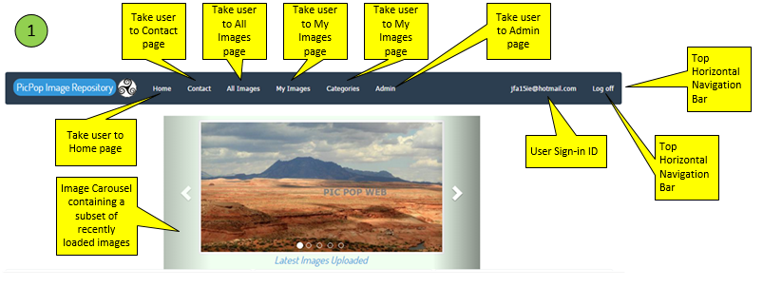

## Register

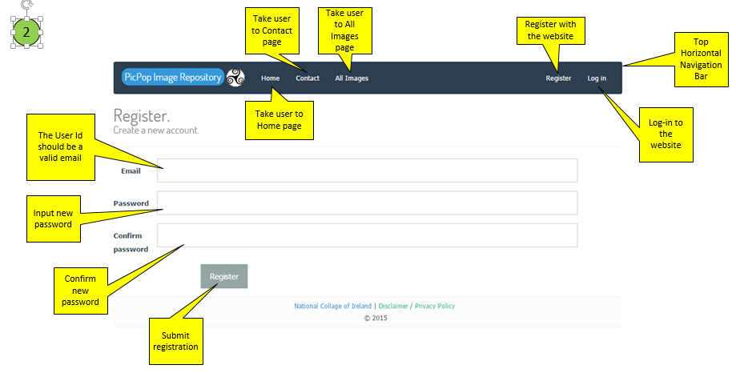

## Login

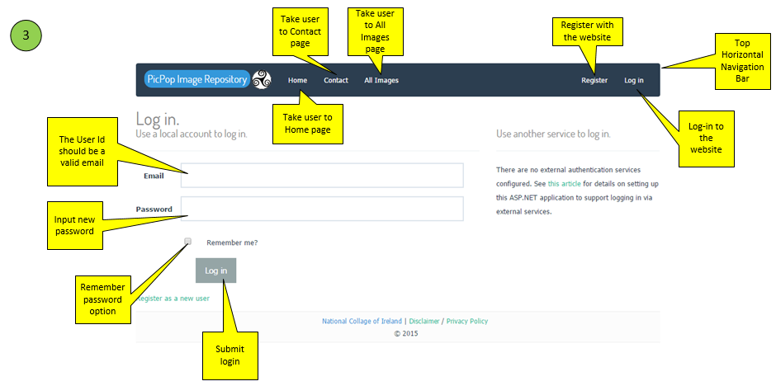

## All Images

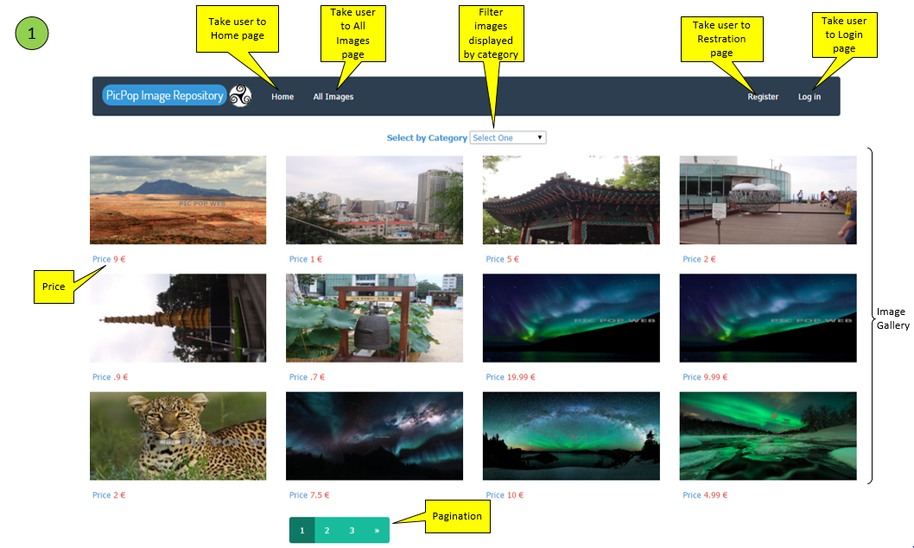

## My Images

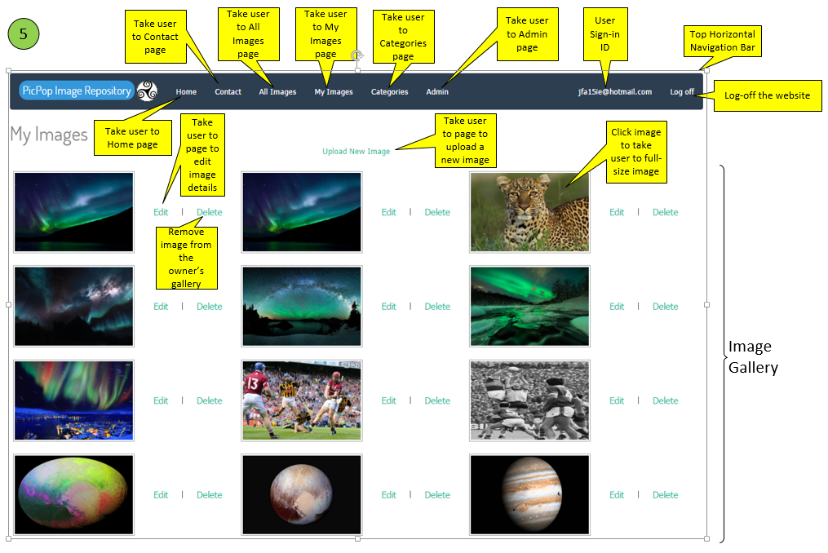

## Image Details

### 

## Categories

### 

## Shopping Cart

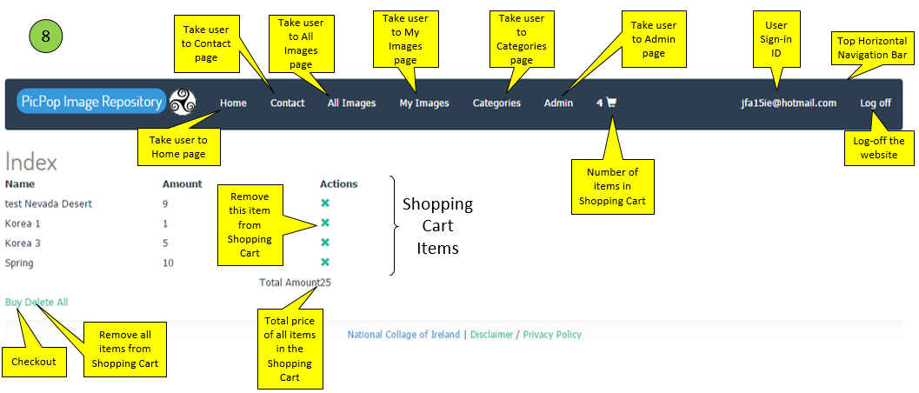

## Admin

### 

### 

## User Roles

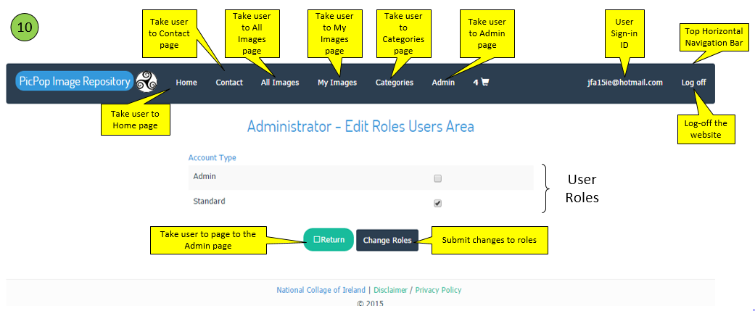

## Contact Us

